Sales Manager Bonus
When you become a Sales Manager you will become eligible for a $2500 BONUS!
Remember, the benefits of becoming a Sales Manager are:
20% commission on every sale you close by yourself!
10% commission on every sale a Sales Agent on your team makes!
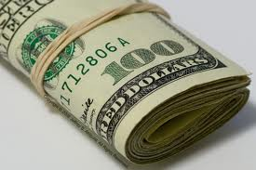

Once you have met the requirements, send an email to your Sales Manager to get things started.

